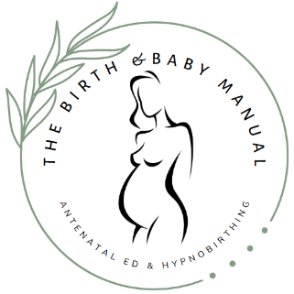**Terms and Conditions**

By signing up to a course with The Birth and Baby Manual you are agreeing to the following.

**Payments**

A non-refundable deposit of £50 is required to confirm your place on your chosen course.

The balance of the course fee must be paid in full at or before the first session of the course. Course fees are non-refundable except under exceptional circumstances.

Payment is made for a full course as advertised and not for individual sessions.

Flexible payment terms must be agreed in advance.

**Cancellations**

In the event of cancellation by a participant prior to the start of the course, the deposit is non-refundable.

In the event of cancellation by a participant after one or more sessions of the course have been completed, no refund will be given.

In the unlikely event of cancellation of a course by myself, attempts will be made to reschedule. If this is not possible, or alternative dates cannot be agreed, a full refund of the total fee will be given.

In the unlikely event of cancellation of an individual session by me, attempts will be made to reschedule. If this is not possible, or if alternative dates cannot be agreed, a refund for sessions not yet taken will be given. If it is not possible for all couples within a group to agree an alternative date then provision will be made for individual couples. The refunded fee per session will be calculated as the total fee, after deduction of the £50 deposit, divided by the number of sessions in the course. No refund will be made for sessions already taken.

If for any reason in person course cannot take place for example extreme weather or government guidelines, the event will either be rescheduled or the course will take place over live video link.

**Rescheduling Sessions**

For participants taking a private one to one course, 48 hours’ notice must be given in changing appointment dates or times. Where this is not done the participants will be liable for the session fee calculated as the total fee, after deduction of the £50 deposit, divided by the number of sessions in the course. Exceptions may be made in exceptional circumstances.

**General**

Participants take part in Hypnobirthing sessions with the understanding that the content of the course is in no way intended to be taken as medical advice. Participants should seek the advice of a health-care provider to answer any health-related or pregnancy-related issues surrounding their pregnancy, their labour or their birth. The Birth and Baby Manual cannot be held responsible for any decisions that you make regarding your pregnancy and birth.

Any questions or doubts you have about the use of Hypnobirthing should be taken up with your health care professionals.

Taking a Hypnobirthing course in no way guarantees a certain birth outcome.

The resources given to you on The Birth and Baby Manual course are for your own personal use and should not be distributed to third parties. Again, these do not represent medical advice.

Please sign to confirm that you have read and understood these terms and conditions

________________________________________ Date ____________________